Biology- Fall 2011 Quarterly Study Guide

- Two students were testing the amount of fertilizer that would best promote the growth of strawberries in a garden. Which of the following could be an unavoidable source of experimental error? (IAE 1b)
- length of the study
B. variation in the strawberry plants
C. the cost of watering the plants
D. fertilization during the study

- Based on the graph in Figure 1 below, what is the distance traveled by grandma after 4 hours? (IAE 1a)
- 8,000 meters
- 12,000 meters
- 16,000 meters
- 24,000 meters

FIGURE 1 Distance Traveled by Grandma
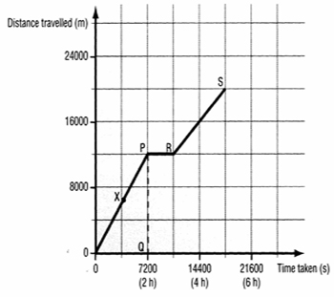
- Looking at the graph above, how long did it take grandma to get to her bingo game located 20,000 meters from her house? (IAE 1a)
- 2 hours
- 4 hours
- 5 hours
- 6 hours

FIGURE 2
Water, 8 drops of indicator, base Diferentiate/Differentiation
r
Water, indicator, Substance Y
Water, indicator, Drano

Water, Vinegar

Water
Water, PH Indicator
3

4
1
2
5

 | 1 | 2 | 3 | 4 | 5
Initial Color | Clear | Purple | Purple | Purple | Purple
Color after 30 minutes | Clear | Purple | Orange | Pink | Pink

- Looking at the beakers in the experiment above, we see that (IAE 1d)
- Substance Y is a cell phone
- Substance Y is a pea plant
- Substance Y is acidic
- Substance Y is basic

- Color the following PH scale according to your biology book on page 43. Add your own acidic substance and basic substance on the blank lines below.

0 (Acidic) 7 (Basic) 14
Stomach Vinegar ___________ Acid Rain Water Soap __________ Draino
Acid

FIGURE 3

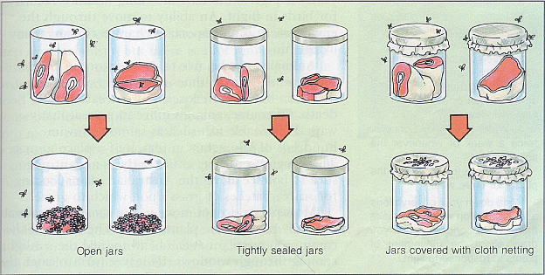

- Looking at Redi’s experiment in Figure 3, we see that he was testing his ________(IAE 1f)
- Hypothesis
- Observation
- Data
- Flies

- If your hypothesis has been supported by multiple experiments, and never proven to be wrong, it can become a(n) _________(IAE 1f)
- Theory
- Inference
- Conclusion
- Song

- How can a hypothesis be tested? (IAE 1f)
- By performing a controlled experiment
- By observing results
- By reading
- By inference

- If comparing data in a plant lab, and one group measures in inches, while another group measures in centimeters, this will affect our results because ______(IAE 1b)
- Plants like to be measured in inches
- Experimental error will not allow us to get accurate results
- Spontaneous generation will cause plants to grow
- Inches and centimeters are the same so it makes no difference

- If we wanted to figure out the average height of a male student at Chula Vista High and avoid experimental error, we would (IAE 1b)
- Measure the heights of 5 males and 3 females in Mr. Swenson’s classroom
- Measure the heights of 3 random males on campus
- Measure the heights of 3 male teachers on campus
- Measure the heights of every male student on campus

- Looking at the table below, which drink is responsible for the greatest increase in height between ages 10 and 18? (IAE 1d)

Beverage | Average Height – cm  (Average Age 10) | Average Height – cm  (Average Age 14) | Average Height – cm  (Average Age 18)
Drink “X” | 100 cm | 175 cm | 200 cm
Drink “Y” | 100 cm | 150 cm | 175 cm
Drink “Z” | 100 cm | 125 cm | 150 cm

- Drink X
- Drink Y
- Drink Z
- Inconclusive

- Which of the following cells could be classified as part of a tree? (Bio 1c)

Picture A Picture B
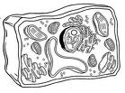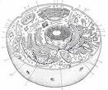
- Picture A
- Picture B
- Both picture A and picture B
- Neither picture A or picture B

- Using the following terms, label the pictures in Figure 4 below (Bio 1c)
- Eukaryotic cell
- Prokaryotic cell
- Virus
- Bacteria

FIGURE 4
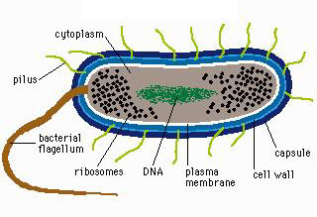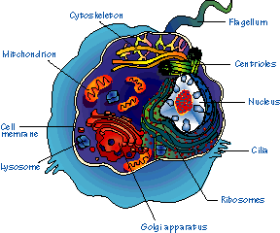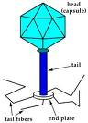

_________________________ ________________________ _______________

_________________________ ________________________ _______________

- Using Figure 4 above, rank the pictures from smallest to largest (Biol 1c)
- ___________________

- ___________________

- ___________________

- Look at Figure 4 above. Where is DNA located in each of the pictures? (Biol 1d)

- __________________________

- __________________________

- __________________________

- Turn to the person next to you and explain in your own words, for 20 seconds, the relationship between DNA and protein. Write down what you learned here: (Biol 1d) ________________________________

_________________________________________________________________________________________

_________________________________________________________________________________________

- Looking at Figure 5, if the solute is moving through the protein channel, this is called (Bio 1a)
- Osmosis
- Diffusion
- Facilitated Diffusion
- Active Transport

FIGURE 5
A
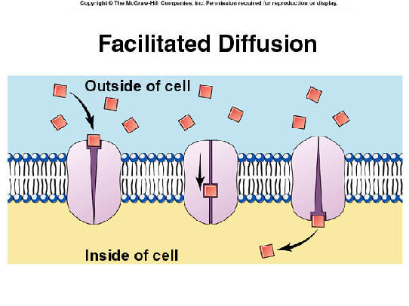
C
B

- Looking at Figure 5 above, in which direction is energy moving? (Bio 1a)
- Top to bottom
- Bottom to top
- Side to side
- Energy does not move

- Looking at Figure 5, name A, B and C (Bio 1a)
- A: Protein Channel B: Lipid Bilayer C: Carbohydrate
- A. Lipid Bilayer B. Carbohydrate C. Protein Channel
- A. Lipid Bilayer B. Protein Channel C. Carbohydrate
- A. Carbohydrate B. Protein Channel C. Lipid Bilayer

- What four main macromolecules are humans made of? (Bio 1h)
- Carbohydrates, lipids, proteins, RNA
- Carbohydrates, lipids, proteins, blood
- Carbohydrates, lipids, proteins, water
- Carbohydrates, lipids, proteins, nucleic acids

- Of the four main macromolecules we are made of, which could you find in a sugar cookie? (Bio 1h)
- Lipids
- Carbohydrates
- Fatty acids
- Proteins

- What is a lipid bilayer made of? (Bio 1h)
- Glycerol and fatty acids
- Blood and water
- Animal cells
- Two stacks of membranes

- Which of the following is an example of nucleic acids? (Bio 1h)
- DNA and RNA
- Fatty acids
- Long chain carbohydrates
- Amino acids

FIGURE 6
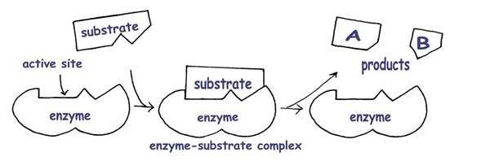
- Explain in your own words what happened to the substrate after it bonded with the enzyme in Figure 6 above (Bio 1b)
_______________________________________________________________________________

_______________________________________________________________________________

- If we place an enzyme in a beaker of hot water with a low PH, (Bio 1b)
- The enzyme will not function
- The enzyme will work better
- The enzyme will not be affected
- The enzyme will turn into a carbohydrate

- Two identical twins have the same proteins that affect skin color. When researchers look at these proteins, they see that (Bio 4e)
- Proteins have the same number of amino acids which are in the same sequence (order)
- Twins have proteins which have the same number of amino acids
- Twins have proteins which are in the same sequence but have different numbers of peptide bonds
- Everyone has the same proteins so we’re all clones

- If we connect 3 amino acids with peptide bonds as shown in Figure 7 below, what do we get? (Bio 1h)
- Protein
- Carbohydrate
- Lipid Bilayer
- Phospholipid
FIGURE 7
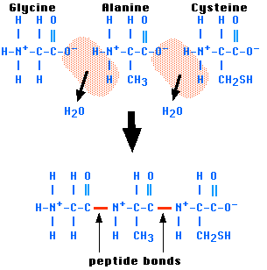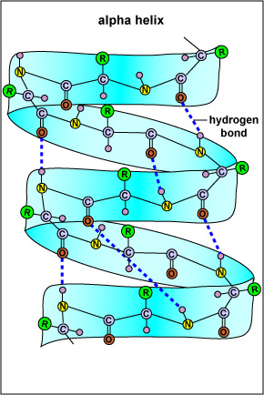

- Using Figure 8 below, write down the reasons your teacher gives you on the differences in speed of the following enzyme-substrate reactions (Bio 1h):
27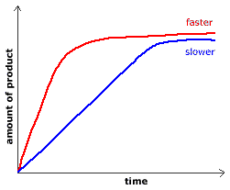 FIGURE 8

